COMMUNIQUÉ DE PRESSE – 29 Juin 2011

« Il y a urgence à faire de la politique européenne des marchés publics, un vecteur de qualité »

La Commission Européenne lance demain le projet de modernisation de l’achat public. Elle évalue à 20 milliards d’euros les économies en Europe induites par sa politique de mise en concurrence des marchés publics. Un non-sens pour EFCA, la fédération européenne de l’ingénierie (CA de 100 milliards d’euros ; 1 million d’emplois), et ACE, le conseil européen des architectes (CA de 17 milliards d’euros et 155 000 architectes), si la qualité n’est pas au rendez-vous. Pour ces fédérations professionnelles, ces économies se jouent souvent au détriment de la qualité globale et à long terme du cadre bâti.

Dans leurs réponses au Livre Vert de la Commission Européenne, ces deux fédérations demandent des changements sur deux axes précis :

- Vers plus de reconnaissance de la conception dans la commande publique :

La conception d’un projet représente au plus 10% du coût total d’une construction, ou 3% du coût d’exploitation et de construction. Un marché de conception ne peut être passé dans les mêmes conditions qu’un marché de fournitures ou de travaux. ACE et EFCA proposent de privilégier la négociation sur leur champ d’intervention. Ils entendent ainsi être reconnus non pas comme de simples fournisseurs, mais comme des partenaires apportant une réelle valeur ajoutée aux projets.

- Vers une approche de qualité « durable » des projets :

Choisir un projet in fine sur le seul critère économique inquiète les ingénieurs et les architectes. C’est mettre en péril la qualité des réalisations et de leurs impacts. Construire un nouvel ouvrage, c’est intégrer les contraintes budgétaires certes, mais aussi plus largement les notions de qualité, de cycle de vie, d’achats verts, propres à toute construction. Un bâti est un ensemble complexe qui se doit d’être réfléchi et durable, pour devenir un véritable lieu de vie des générations futures.

Il y a donc urgence aux yeux des professionnels de la conception de refonder la politique européenne en matière de marché public. Les ingénieurs et les architectes unissent leurs voix pour encourager un changement de mentalité à Bruxelles. Passer d’un esprit de « value for money » vers un état d’esprit enraciné dans « quality for money ».

A propos de l’OAI
L’Ordre des Architectes et des Ingénieurs-Conseils est un établissement public regroupe 455 bureaux d’architectes et les 173 bureaux d’ingénieurs-conseils au Luxembourg employant près de 4 000 personnes.

Source de la traduction française : Syntec-Ingénierie, France.

Personne de contact: Pierre Hurt, Directeur de l’OAI
Tél: 42 24 06 ; fax: 42 24 07 ; email: oai@oai.lu
Internet : www.oai.lu

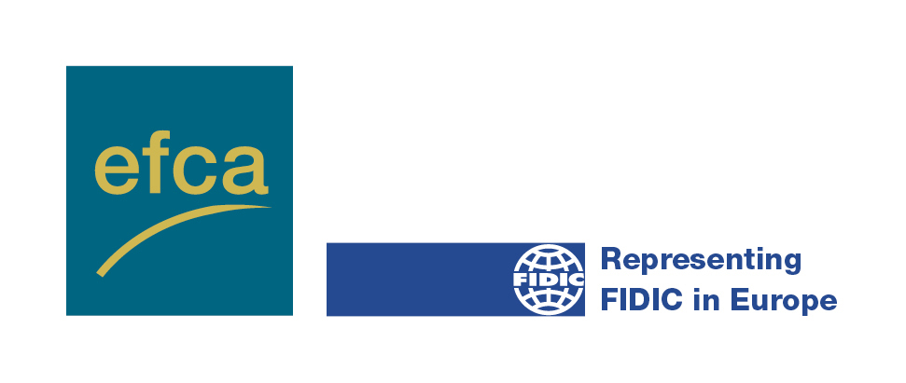 | 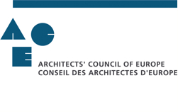

29thJune 2011

Changes urged for procurement policy and regulation to better support global quality

Architects and consulting engineers join forces to draw the attention of the European legislators drafting a new European policy and regulation on public procurement to the fact that quality criteria are a fundamental requirement in public procurement, and should thus be given full consideration in the awarding procedure. The European Commission’s claim of EUR 20 billion in savings through increased European competition is meaningless if there is no simultaneous increase in global quality. The value for money principle, as implicitly considered in pure financial terms in the former 1992 and 2004 directives on public procurement, has to be fundamentally reviewed, with a correlated improvement through the modernisation of EU public procurement that will be initiated at the European Commission Conference taking place tomorrow.

The European Federation of Engineering Consultancy Associations (EFCA) and the Architects’ Council of Europe (ACE), representing the technology based intellectual service providers in Europe, welcome the Green Paper on the modernisation of EU public procurement policy: Towards a more efficient European Procurement Market.

Both federations, ACE and EFCA, are grateful for the opportunity offered to comment on the Green Paper on public procurement. Their replies are based on their experience on how EU procurement policy can be improved.

Architects and consulting engineers play a key role in the sustainability of public projects by incorporating the latest technologies and innovations, having access to pertinent information and bringing quality expertise to the initial design phases. But this means that the tendering process must allow for more quality criteria during the selection stage – because basing final decisions on lowest cost is creating abnormally low-priced offers and can be a false economy in the long run.

In their proposals, ACE and EFCA are calling for changes in two main areas:
- the position of creative intellectual services in the procurement chain;
- value-for-money, considering a selection process with more emphasis on quality, life cycle cost approach and green procurement.

Intellectual creative services are more than suppliers; they are trusted advisors

In this respect, EFCA President Jan Bosschem said that “Architects and consulting engineering are trusted advisors to clients, they offer creative services. Design and management services account for just 10% of overall construction costs, or 3% of construction and operation costs. Therefore, intellectual services cannot be tendered in the same way as commodities, and the procedures and selection criteria need to reflect that.” ACE and EFCA propose a phased approach, based on a negotiated procedure that allows for discussion on project scope and remuneration with the best technical team.

ACE President Selma Harrington commented “The problem is exacerbated for most SMEs which, because of their size, have major difficulty in accessing the European public market. For the future, architects and consulting engineers should be considered as expert networkers with sophisticated systems to synthesise information and best practices from many countries and sectors, to source resources and find best solutions for a client.”

More emphasis on quality

Among the awarding criteria the lowest price still plays a detrimental role. In the awarding of architectural and engineering services, the awarding criteria are often, in fact, restricted to the price; life-cycle costs and sustainability and environmental issues still do not play a predominant role.

The directives should in the future provide for a strictly quality-based awarding of contracts in the sector of architecture and engineering. The current awarding practice conflicts fundamentally with the respective EU policies aiming at sustainable development.

At the time of the previous revision of the procurement directive in 2004, sustainability and life cycle cost considerations were less considered than today. It is time to change this. The current policy review provides the opportunity to create market conditions in which independent creative intellectual services can effectively offer high-quality, innovative and sustainable solutions.

Jan Bosschem Selma Harrington
EFCA President ACE President

___ENDS___

EFCA has member associations in 26 countries, and is the sole European federation representing the business interests of professional engineering consultancy and related services, a sector that employs around one million staff in Europe. | ACE is the representative body for the architectural profession in the European Union. It has 45 member organisations and represents over 450,000 practising architects.
Jan Van der Putten  Secretary-General  EFCA  Avenue des Arts 3-5  B-1210 Brussels  Belgium  Tel: +32 209 07 70  Email: jvanderputten@efca.be  www.efcanet.org | Selma Harrington  President  ACE  29 rue Paul Emile Jansen  B-1050 Brussels  Belgium  Tel: +32 2 543 11 40  Email: president@ace-cae.eu  www.ace-cae.eu

